**ER Model**

**1. Entities and Attributes:**

**User**

* UserID (PK)
* Name
* Email
* Password
* PhoneNumber
* Address
* Role (e.g., Buyer, Seller, Agent, Admin)

**Property**

* PropertyID (PK)
* Title
* Description
* Price
* Type (e.g., Sale, Rent)
* Location
* Size
* NumberOfRooms
* AgentID (FK)
* SellerID (FK)

**Agent**

* AgentID (PK)
* Name
* Email
* PhoneNumber
* CompanyName

**Review**

* ReviewID (PK)
* UserID (FK)
* PropertyID (FK)
* Rating
* Comment
* Date

**Message**

* MessageID (PK)
* SenderID (FK)
* ReceiverID (FK)
* PropertyID (FK)
* Content
* Date

**Admin**

* AdminID (PK)
* Name
* Email
* PhoneNumber

# Entity Relationship Diagram

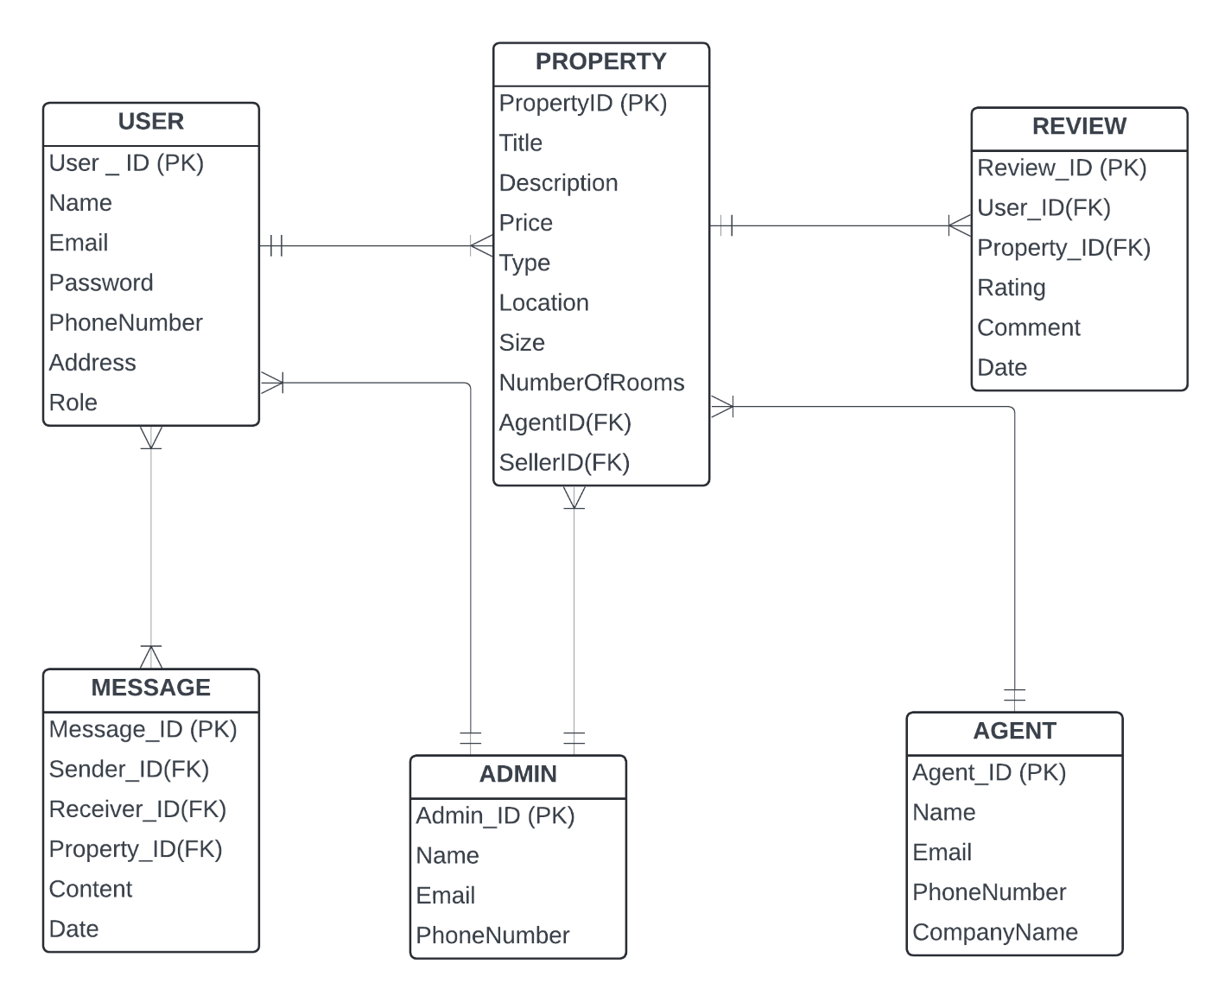

**2. Relationships:**

* **User - Property:** One-to-Many (One user can list multiple properties)
* **Property - Review:** One-to-Many (One property can have multiple reviews)
* **User - Message:** Many-to-Many (Users can send messages to each other)
* **Agent - Property:** One-to-Many (One agent can manage multiple properties)
* **Admin - User/Property:** Admins manage multiple users and properties

# **SQL Schema**

CREATE TABLE User (

UserID INT PRIMARY KEY,

Name VARCHAR(255) NOT NULL,

Email VARCHAR(255) UNIQUE NOT NULL CHECK(Email like '%@%'),

Password VARCHAR(255) NOT NULL,

PhoneNumber VARCHAR(15),

Address VARCHAR(500),

Role varchar(50) NOT NULL

);

CREATE TABLE Property (

PropertyID CHAR(36) PRIMARY KEY,

Title VARCHAR(255) NOT NULL,

Description VARCHAR(1000),

Price DECIMAL(15, 2) NOT NULL,

Type ENUM('Sale', 'Rent') NOT NULL,

Location VARCHAR(255) NOT NULL,

Size DECIMAL(10, 2),

NumberOfRooms INT,

AgentID CHAR(36),

SellerID CHAR(36),

FOREIGN KEY (AgentID) REFERENCES Agent(AgentID),

FOREIGN KEY (SellerID) REFERENCES User(UserID)

);

CREATE TABLE Agent (

AgentID INT PRIMARY KEY,

Name VARCHAR(255) NOT NULL,

Email VARCHAR(255) UNIQUE NOT NULL CHECK(Email like '%@%'),

Password varchar(25) NOT NULL,

PhoneNumber VARCHAR(15),

CompanyName VARCHAR(255)

);

CREATE TABLE savedListings (

UserID int,

PropertyID int,

primary key(UserID,PropertyID),

postDate DATE,

FOREIGN KEY (UserID) REFERENCES Users(UserID),

FOREIGN KEY (PropertyID) REFERENCES Property(PropertyID)

)

CREATE TABLE record (

recordid int primary key,

PropertyID int,

TypeOfChange varchar(100),

updateprice decimal,

status varchar(50),

postDate DATE,

FOREIGN KEY (PropertyID) REFERENCES Property(PropertyID)

)

CREATE TABLE Reviews (

ReviewID int PRIMARY KEY,

UserID int,

PropertyID int,

Rating INT CHECK (Rating BETWEEN 1 AND 5),

Comments VARCHAR(1000),

postDate DATE,

FOREIGN KEY (UserID) REFERENCES Users(UserID),

FOREIGN KEY (PropertyID) REFERENCES Property(PropertyID)

)

CREATE TABLE Message (

MessageID int PRIMARY KEY,

SenderID int,

ReceiverID int,

Content VARCHAR(1000) NOT NULL,

currDate DATE NOT NULL,

FOREIGN KEY (SenderID) REFERENCES Users(UserID),

FOREIGN KEY (ReceiverID) REFERENCES Users(UserID)

)

CREATE TABLE Admin (

AdminID CHAR(36) PRIMARY KEY,

Name VARCHAR(255) NOT NULL,

Email VARCHAR(255) UNIQUE NOT NULL,

Password varchar(25) ,

PhoneNumber VARCHAR(15)

);